Class Diagram

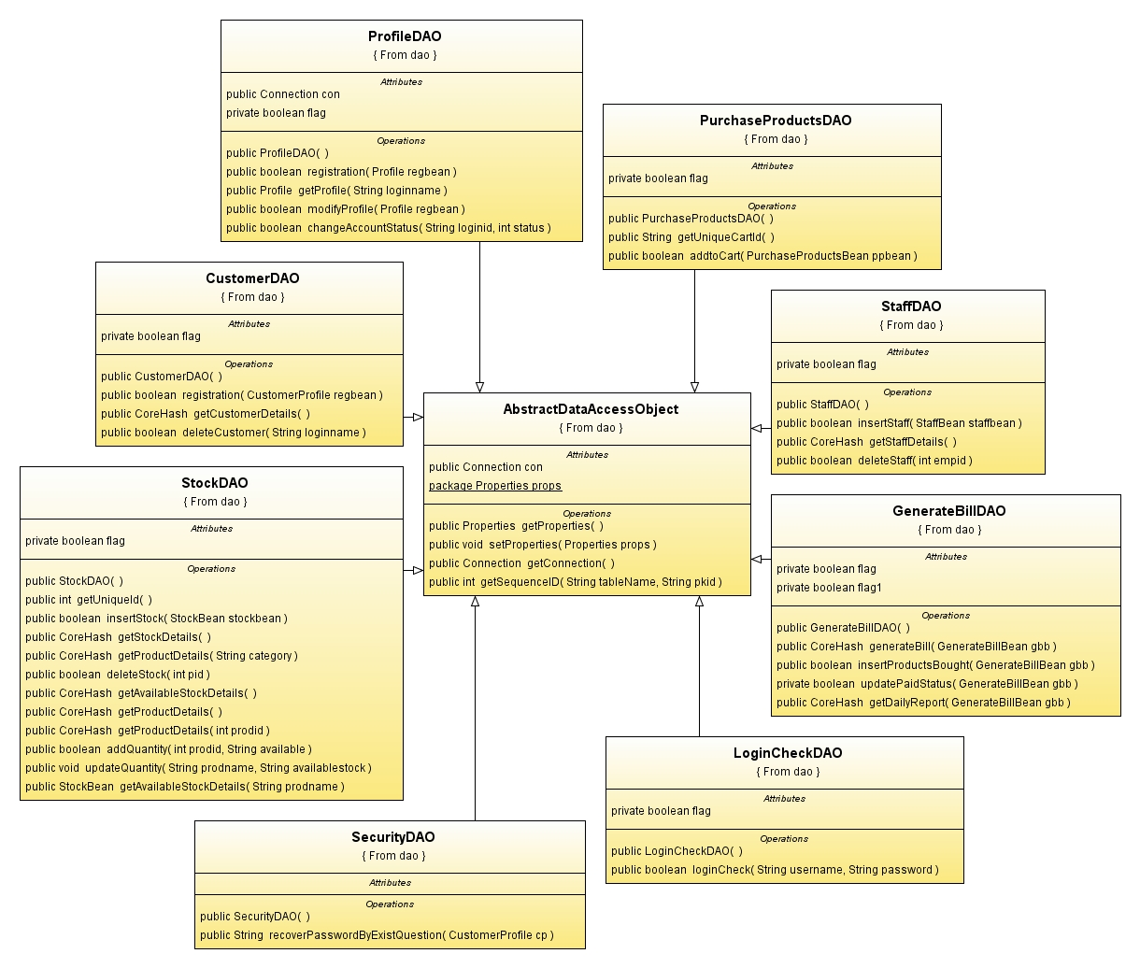
Fig: 2.4.1. Class diagram
Use-case Diagrams
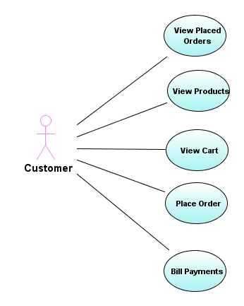
Fig: 2.4.2. Use case diagram for Customer.

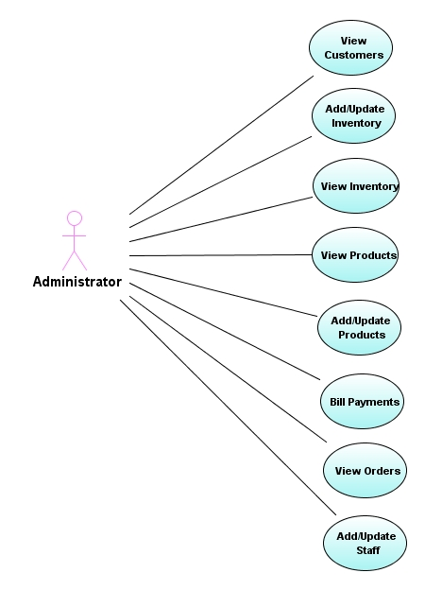
Fig: 2.4.3. Use case diagram for Administrator.
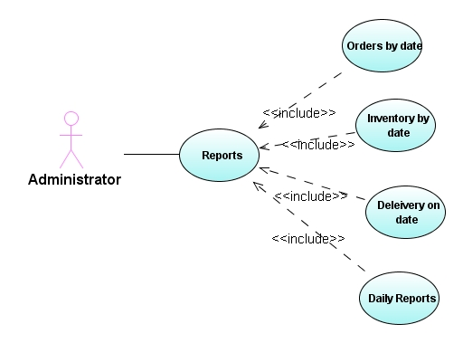
Fig: 2.4.4. Use case diagram for reports.

Sequence Diagrams

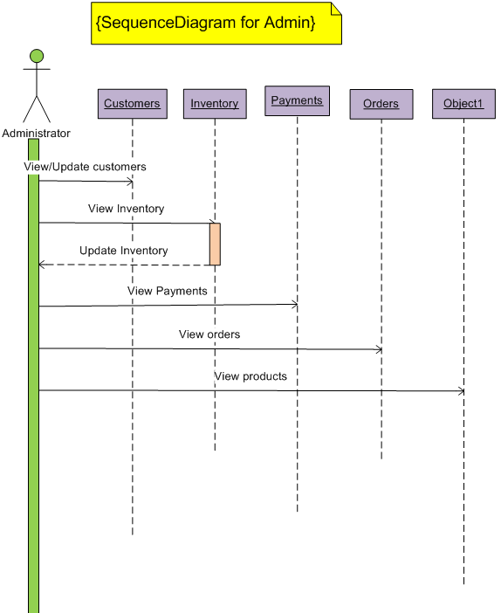
Fig: 2.4.5. Sequence diagram one for admin.

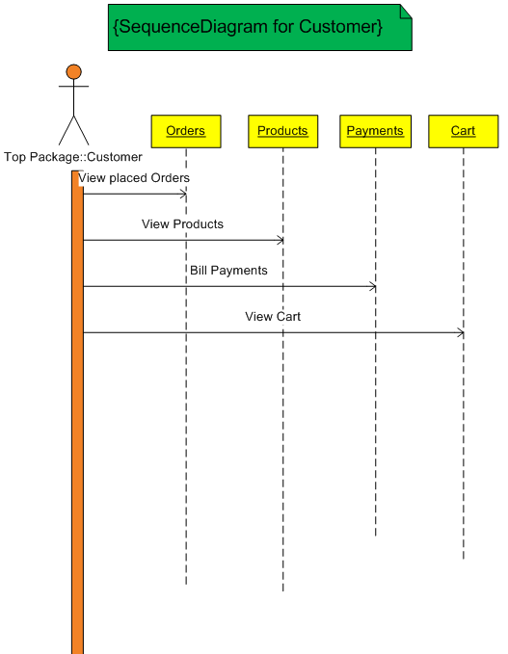
Fig: 2.4.6.Sequence Diagrams two for Customer.

Component Diagram
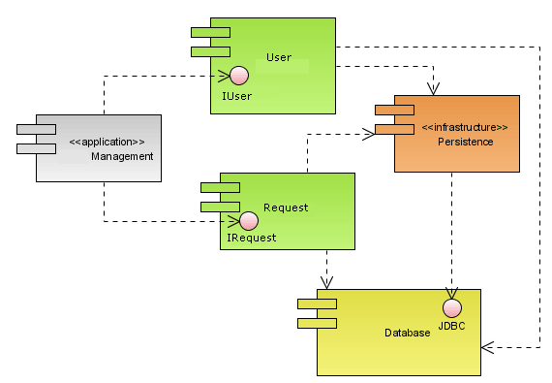
Fig: 2.4.7. Component diagram.

Deployment Diagram
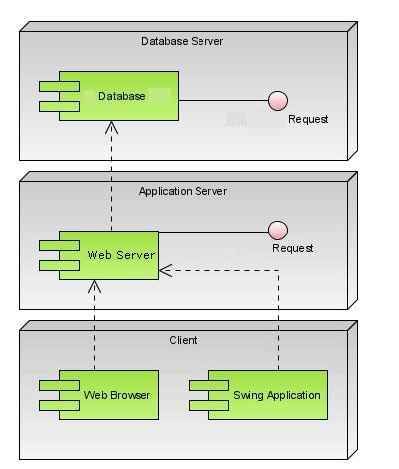
Fig: 2.4.8. Deployment diagram one.

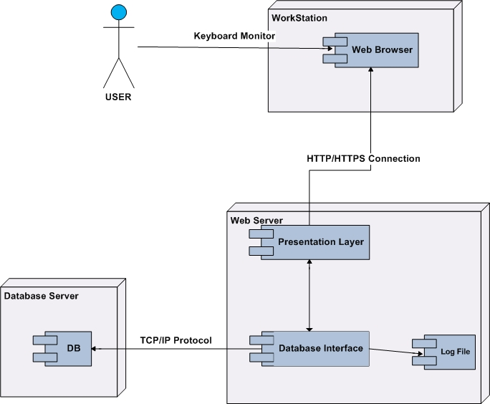
Fig: 2.4.9. Deployment diagram two.

Activity Diagram:-

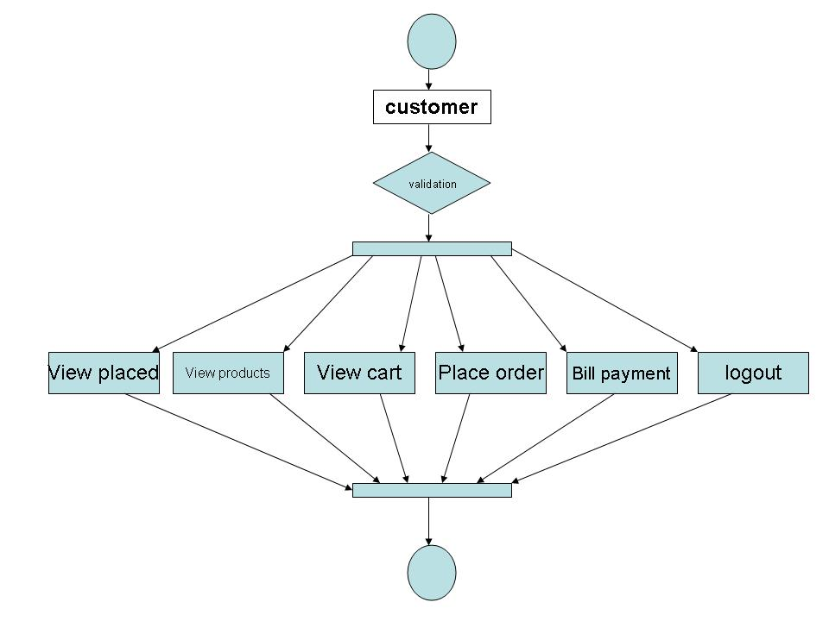

State Diagram

Login
User ID,
Password
UnAuthentication
Validation
Invalid

valid

Authentication

